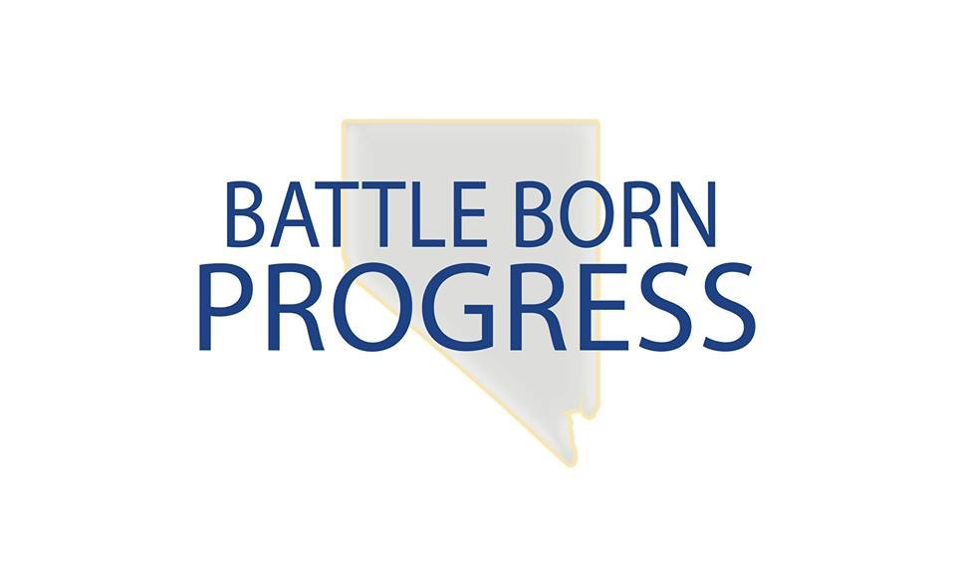
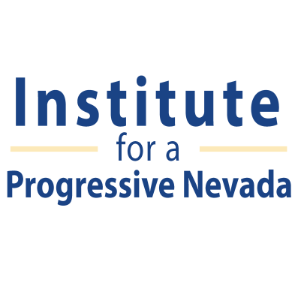

Mission: Institute for a Progressive Nevada (IPN) educates, empowers and engages Nevadans to build a state where everyone has a fair opportunity to succeed.
Mission: Battle Born Progress (BBP) through strategic communication, efforts empowers, engages and mobilizes Nevada voters to build a state where everyone has a fair opportunity to succeed.
Job Title: Southern Nevada Gun Violence Prevention Community Organizer
Reports to: Institute for a Progressive Nevada and Battle Born Progress Staff
Job Summary: The position of Southern Nevada Gun Violence Prevention Community Organizer will work with the senior staff of IPN and BBP, and collaborate closely with our community partners. The organizer’s main responsibility will be to assist external stakeholders with grassroots and grasstops organizing and mobilization efforts, and to support advocacy, education, and communications across the state.
Primary Duties and Responsibilities:
- Continue building and creating new relationships with gun violence prevention advocates and maintain regular contact with them
- Assist and manage coalition building
- Assist in building out trainings for our rapid response team members and community partners
- Assist with the creation of messaging for activists
- Manage all grassroots organizing during the legislature and beyond for this topic
- Collect petitions to help grow our list and create a database of potential voters
- Use new media and social media programs as a way to communicate with the community
- Provide message trainings in both Spanish and English when possible
- Engage the media when needed
- Recruit and engage new volunteers
- Plan and coordinate monthly events
- Work with the Silver State Voice Data Manager to input all data in a weekly basis in both the VAN and PNN systems
- Provide weekly reports with specific numbers and data

Qualifications:
- Passion for promoting positive social change
- Ability to set and achieve goals independently and as a team
- Ability to motivate and manage a group of passionate activists and volunteers
- Excellent organizational skills and communication (written and oral) skills in both English and Spanish preferred
- Proficiency with MS Word, Excel, Power Point. Knowledge of social media platforms and the Voter Activation Network (VAN) is a plus.
- Reliable transportation and ability to work long hours

Location: Southern Nevada
Term: Grant funded position through December
Salary: Salaried full-time position plus monthly car and phone allowances. Health insurance offered.

To Apply: Send resume and cover letter to our Las Vegas office at ckravitz@battlebornprogress.org by close of business on 8/8/16

